CHAPTER 2
GENERAL PROVISIONS
SECTION:
15-2-1: Regulation Application
15-2-2: Limitation On Land Use; Prohibition
15-2-3: Exceptions To Building Height
15-2-4: Height Restrictions For Walls And Fences
15-2-5: Reserved
15-2-6: Corner And Alley Clearance
15-2-7: Encroachments
15-2-8: Screening
15-2-9: Public Facilities
15-2-10: Temporary Buildings
15-2-11: Driveway Visibility
15-2-12: Carnivals
15-2-13: Conditional Use Permits For Airports Or Heliport Landing Fields
15-2-14: Landscaping
15-2-15: Outdoor Dining Areas
15-2-1: REGULATION APPLICATION:
The following regulations shall pertain to the various zoning districts within the City. (Ord. 1212, 11-16-1993)
15-2-2: LIMITATION ON LAND USE; PROHIBITION:
Except as provided in this title, it is unlawful to construct, reconstruct, or structurally alter any building or use any real property for any purpose other than is specifically permitted in the zone in which the building or land is located. Using any building or real property for a purpose prohibited by Federal law, State law, or this Code is a misdemeanor. (Ord. 1401, 10-3-2006)
15-2-3: EXCEPTIONS TO BUILDING HEIGHT:
Penthouses or roof structures for the housing of elevators, stairways, solar panels and related equipment, or mechanical and similar equipment required to operate and maintain a building, fire escapes, open-work guardrails, skylights, clock towers, church steeples and other similar architectural elements, flagpoles, chimneys, smokestacks, radio antennas, and other similar structures may be erected above the height limits prescribed in this title. Light standards or other light fixtures may be mounted on the roof of a parking structure and must be designed to control glare. Non-permanent accessories, such as furniture, barbeques, or umbrellas placed on a roof deck may be erected up to a maximum eight feet (8') above the height limits prescribed in this title. No such penthouse, structure or accessory is allowed for the purpose of providing additional floor space. Any such structures in Residential Zones shall be for noncommercial purposes only.
An increase in the maximum allowable building height, up to five feet (5'), may be granted by the Director, subject to the approval of an adjustment pursuant to chapter 24 of this title. (Ord. 1571, 9-4-2018)
15-2-4: HEIGHT RESTRICTIONS FOR WALLS AND FENCES:
A. Residential zones. A wall or fence 42 inches in height may be located on any part of a lot. On an interior or corner lot, a wall or fence up to six feet in height may be located anywhere on the lot behind the required front yard. On a reversed corner lot, a wall or fence up to six feet in height may be maintained anywhere on the lot behind the required front yard except within the required triangular open area at the rear constituting a part of the required side yard of the street side. The provisions of sections 15-2-6 and 15-2-11 of this chapter shall apply to walls and fences adjacent to corners and driveways.
1. Retaining Walls:
a. Where a retaining wall protects a cut slope below the natural grade, as depicted in subsection 15-2-4A-4, the retaining wall may be topped by a fence or wall of a height equal to that which would otherwise be permitted at that location This does not apply to retaining walls which protect a fill slope.
b. A retaining wall that protects a cut slope located in a required front or streetside setback is limited to three feet in height.
c. Where a retaining wall contains a fill and is not located in any required setback, as depicted in subsection 15-2-4A-4, the height of the wall retaining the fill is considered as contributing to the permissible height of a fence or wall. If required by the California Residential Code, an open work fence or guardrail, not more than 42 inches in height, may be erected on top of a retaining wall. An "open work fence" means a fence in which the component solid portions are evenly distributed, vertically oriented, and constitute not more than 25 percent of the total surface area of the fence.
d. A retaining wall located in any required setback, as depicted in subsection 15-2-4A-4, may retain a maximum of three feet of fill. The height of the retaining wall built to retain the fill is considered as contributing to the permissible height of a fence or wall.
In a required side or rear setback, if required by the California Residential Code, an open work fence or guardrail, not more than 42 inches in height, may be erected on top of a retaining wall. However, the maximum height of the fence and/or wall including a required openwork fence or guardrail is limited to six feet six inches.
In a required front setback, a six-inch wall or fence may be erected on top of a wall which retains a maximum of three feet. No open work fence, above the maximum 42-inch total height, is allowed in the front setback.
2. Exceptions: The provisions of this section shall not apply to fences required by State law to surround and enclose public utility installations or to chainlink fences enclosing school grounds and public playgrounds.
3. Adjustments: A wall or fence up to eight feet in height may be allowed in residential zones subject to the approval of an adjustment, pursuant to chapters 22 and 23 of this title. A variance is required for a wall or fence in a residential zone which exceeds eight feet in height.
4. Figures And Diagrams:
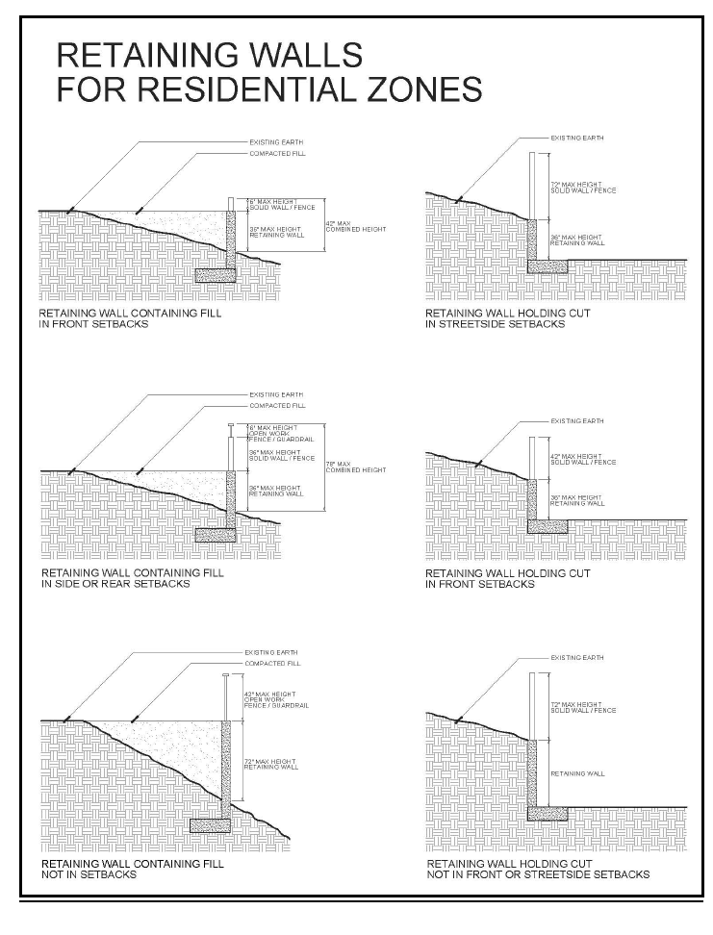
B. Non-residential zones. Open work fences up to eight feet in height may be located on any part of a lot. Solid fences or walls up to six feet in height may be located and maintained on any part of a lot behind the required front and street side setbacks. Solid fences or walls up to 42 inches in height may be located in a required front or street side setback.
Required walls. When abutting properties with a different zoning designation, a six-foot high masonry wall shall be provided along the common property lines.
1. Retaining walls
a. Where a retaining wall protects a cut slope below the natural grade, as depicted in subsection 15-2-4B-4, the retaining wall may be topped by a fence or wall of a height equal to that which would otherwise be permitted at that location. This does not apply to retaining walls which protect a fill slope.
b. A retaining wall that protects a cut slope located in a required front or streetside setback is limited to three feet in height.
c. Where a retaining wall contains a fill and is not located in any required setback, as depicted in subsection 15-2-4B-4, the height of the wall retaining the fill is considered as contributing to the permissible height of a fence or wall. If required by the California Building Code, an open work fence or guardrail, not more than 42 inches in height, may be erected on top of a retaining wall. An "open work fence" means a fence in which the component solid portions are evenly distributed, vertically oriented, and constitute not more than 25 percent of the total surface area of the fence.
d. A retaining wall located in any required setback, as depicted in subsection 15-2-4B-4, may retain a maximum of three feet of fill. The height of the retaining wall built to retain the fill is considered as contributing to the permissible height of a fence or wall.
In a required side or rear setback, if required by the California Building Code, an open work fence or guardrail, not more than 42 inches in height, may be erected on top of a retaining wall. However, the maximum height of the fence and/or wall including a required openwork fence or guardrail is limited to eight feet.
2. Exceptions: The provisions of this section shall not apply to fences required by state law to surround and enclose public utility installations or to chainlink fences enclosing school grounds and public playgrounds.
3. Adjustments: If there is a City-verified nuisance, criminal activity, or extraordinary topographical circumstances, a wall or fence may exceed the maximum permitted height by up to two feet subject to the approval of an adjustment by the Director, pursuant to chapters 22 and 23 of this title. A wall or fence may exceed the permitted height by more than two feet subject to the approval of an adjustment by the Planning Commission, pursuant to chapters 22 and 28 of this title.
4. Figures And Diagrams:
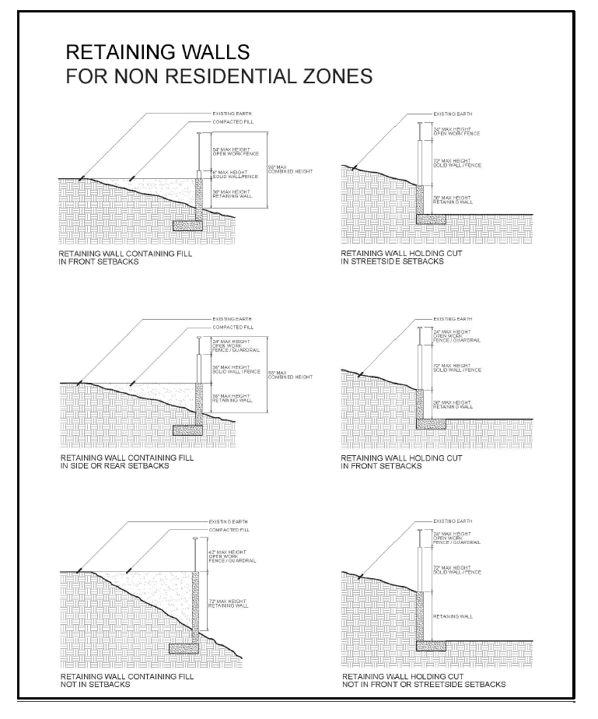
C. Temporary Construction Fencing. Construction projects that are accessible from a street right-of-way or an abutting property and which remain in operation or expect to remain in operation for over 30 calendar days shall provide temporary construction fencing, as defined in Section 15-1-6 (Fence, Temporary Construction) of this code. Unless required to protect against a safety hazard, temporary construction fencing shall not be erected sooner than 15 days prior to commencement of construction. Once erected, temporary construction fencing shall be subject to the following standards and conditions:
1. The temporary construction fencing shall surround all safety hazards, as required by the building official, and shall prevent unauthorized entry to the subject parcel;
2. The temporary construction fencing shall adequately screen outdoor storage of construction equipment and materials as determined by the Director. Chain linked fencing with a mesh screen in addition to the material identified in ESMC Section 15-2-8 may be used as temporary construction fencing;
3. During construction, the subject temporary fencing shall be maintained in a satisfactory condition as determined by the Director; and
4. Temporary construction fencing shall be maintained in a satisfactory condition as determined by the Director, and shall be removed, unless such removal would create a safety hazard, as determined by the director or the city's building official, within 30 days of the following occurrences:
a. The expiration or withdrawal of the building/grading permit for development of the fenced parcel; or
b. Issuance of the final building/grading permit approval or certificate of occupancy for the development of the fenced parcel.
5. If temporary construction fencing is determined by the director or the city's building official to be necessary to protect against a safety hazard or attractive nuisance, the temporary fencing may be erected for a period of 180 days or for a longer period, as permitted by the building official until the hazard or nuisance is abated, after which the property owner shall either remove the temporary fencing or replace the temporary fencing with permanent fencing.
(Ord. 1551, 8-15-2017; amd. Ord. 1648, 6-21-2023)
15-2-5: RESERVED:
(Ord. 1648, 6-21-2023)
15-2-6: CORNER AND ALLEY CLEARANCE:
For the purpose of safe visibility, all corner lots, and reversed corner lots must maintain a triangular area, described as follows: one angle must be formed by the front and side property lines, and the sides of this angle must be 15 feet in length, measured along the front and side property lines; the third side of this triangle must be a straight line connecting the two (2) other lines at their endpoints.
Lots located at the intersection of a public street and an alley must maintain a triangular area, described as follows: one angle must be formed by the property lines abutting the street and the alley, and the sides of this angle must be five feet in length. The third side of this triangle must be a straight line connecting the two other lines at their endpoints. Along alleys that are more than 15 feet wide, this triangle must be located only on the lot to the right of the alley as seen from a vehicle exiting the alley to enter the adjacent street.
Within the area comprising these triangles, no trees, fences, shrubs, retaining walls, buildings and structures, or other physical obstructions may exceed 30 inches in height from street grade, unless it is a tree which is trimmed to provide a minimum of 12 feet (of visibility from street grade under the canopy created by the branches.
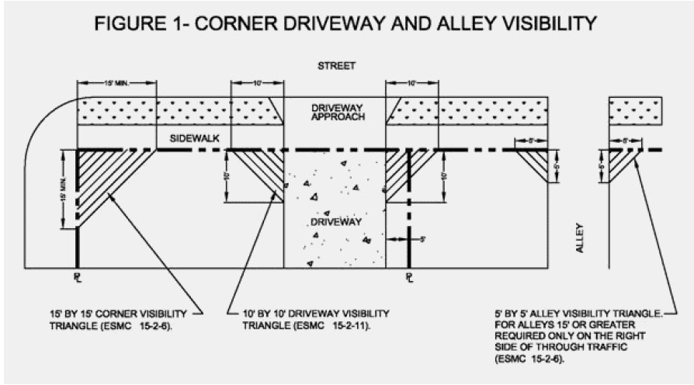

(Ord. 1551, 8-15-2017; amd. Ord. 1648, 6-21-2023)
15-2-7: ENCROACHMENTS:
Encroachments are subject to the following provisions in the indicated zones:
A. All Zones: Every required yard must be open and unobstructed from the ground up, except the following intrusions may project two feet into required yards, provided the required yard cannot be reduced to less than three feet in width:
1. Bay and greenhouse windows, on the first floor in any setback and on the second floor only in the front yard setback, provided that said window is not wider than eight feet measured in the general direction of the wall of which it is a part;
2. Cornices, corbels, columns, belt courses, sills, eaves or other similar architectural building features as defined in section 15-1-6 of this title. Eaves may project six inches into any nonconforming side or rear yard which is three feet in width;
3. Fireplace structures not wider than eight feet measured in the general direction of the wall of which it is a part;
4. Planting boxes or masonry planters not exceeding 42 inches in height;
5. Uncovered porches, platforms and landings which do not extend above the floor level of the first floor. Ramps, stairs, and safety guardrails leading to said porches, platforms and landings may encroach further into a required setback but must maintain at least a three-foot distance to a property line; and
6. "Architectural landscape features" as defined in section 15-1-6 of this title may encroach into setbacks as specified in section 15-2-14 of this chapter.
B. Residential Zones: In Residential Zoning Districts:
1 A porte-cochere (open carport) may be placed over a driveway in the front 20 feet of one side yard setback, outside of the front yard setback, or attached to the front 20 feet of one dwelling unit closest to the front lot line, provided the structure is not more than one story in height; is unenclosed on three sides; and is entirely open except for the necessary supporting columns and architectural features.
2. Mechanical equipment, such as pool heaters, water heaters, air conditioners, and solar energy system appurtenances not wider than eight feet measured in the general direction of the wall of which it is a part, and adequately soundproofed, may project two feet into required side and rear yards, provided the required yard cannot be reduced to less than three feet.
3. Detached arbors, pergolas, or trellises that partially cover a walkway and do not exceed eight feet in overall height, six feet in width, and five feet in length may have a zero setback in the front and street-side yards. However, the structures must comply with the requirements of sections 15-2-6, "Corner And Alley Clearance", and 15-2-11, "Driveway Visibility", of this chapter.
4. Uncovered porches, platforms and landings which do not exceed 12 inches in height above finished grade may have a zero setback in non-street fronting side and rear yards.
5. Built-in barbeques may have a zero setback in non-street fronting side and rear yards provided that the structures:
a. Have no trellis or similar cover;
b. Are placed adjacent to an existing solid wall;
c. Do not exceed the maximum height of the adjacent solid wall, up to a maximum of six feet;
d. Are less than 120 square feet in size;
e. Are located a minimum of three feet from an adjacent structure; and
f. Are consistent with the California Fire Code.
C. Nonresidential Zones: In nonresidential zoning districts, mechanical equipment and accessory structures that do not contain occupied space, as defined by the California Building Code adopted by this Code, or that do not contain net floor area, as defined in section 15-1-6 of this title, may be located within a required interior side or rear setback area.
1. Mechanical equipment includes emergency generators; air conditioning and heating units; transformers; solar energy system appurtenances; and other equipment that is accessory to the principal permitted use. Mechanical equipment does not include electrical substations.
2. Accessory structures include trash and recycling enclosures; ground-mounted and covered parking solar energy systems; and structures that exclusively house building operating equipment that is accessory to the principal permitted use.
3. Mechanical equipment and non-occupied accessory structures within a required setback are subject to the following requirements:
a. The mechanical equipment or accessory structure may not be higher than 18 feet.
b. The mechanical equipment or accessory structure may not be longer than 60 feet parallel to the line of the property to which it is situated or longer than 35 percent of the length of such property line to which it is situated, whichever is less.
c. The mechanical equipment or accessory structure may not be located within a required interior side or rear setback area if the interior side or rear property line abuts a residentially zoned property or abuts a public street.
d. Operation of the mechanical equipment must not exceed the noise standards for commercial and industrial property as identified in this Code.
e. The mechanical equipment or accessory structure must be set back from any interior side or rear property line to meet all access, safety, and screening requirements as specified in title 13 of this Code and this title, including, but not limited to, adequate ingress and egress for public safety employees.
D. Urban Mixed Use North (MU-N), Urban Mixed Use South (MU-S), Corporate Office (CO) And Light Industrial (M-1) Zones: In addition to the encroachments permitted in nonresidential zoning districts generally, patios, decks, and similar outdoor areas used as gathering spaces; and outdoor dining areas, may be located within setback areas as follows:
1. Stairs, pedestrian ramps, and related safety guardrails must maintain at least a three-foot distance to a lot line.
2. Patios, decks, and similar outdoor areas used as gathering spaces, and outdoor dining areas must be enclosed by walls, fences, and/or hedges. These may be up to 42 inches in height and maintain at least a five-foot distance to a property line. Walls, fences, and/or hedges may exceed 42 inches in height, provided that the portion exceeding 42 inches in height is of a transparent or translucent material, subject to the review and approval of the Director. These areas may be covered by a nonsolid trellis or pergola; or by a retractable awning, large umbrella or other similar nonpermanent cover which provides protection from rain, subject to the approval by the Director. (Ord. 1588, 9-3-2019; amd. Ord. 1648, 6-21-2023)
15-2-8: SCREENING:
Equipment must be screened in the following manner:
A. Electrical Lines; Cables: All electrical, telephone, cable television and similar service wires and cables which provide direct service to the property being developed, within the exterior boundary lines of such property, must be installed underground. Risers on poles and buildings are permitted and must be provided by the developer or owner onto the pole which provides service to said property. Utility service poles may be placed on the rear of the property to be developed only for the purpose of terminating underground facilities. The developer or owner is responsible for complying with the requirements of this section and must make the necessary arrangements with the utility companies for the installation of such facilities.
B. Equipment; Appurtenances: Equipment and appurtenances such as, but not limited to, surface mounted transformers, pedestal mounted terminal boxes and meter cabinets, sprinkler manifolds and concealed ducts in an underground system may be placed above ground, provided that they are located in a fully enclosed structure or are screened from public view to the satisfaction of the Director. Screening must sufficiently obstruct view of said equipment from public rights-of-way surrounding the equipment location. Screening material may include masonry, metal, wood, vinyl or similar durable material. Screening may be up to 30 percent open on the vertical surface, for example, perforated, lattice, louvered, and stacked. Chain link fencing may not be used for screening equipment. All vent pipes and similar devices which are attached to a building must be painted to match the building.
C. Rooftop Installation: Mechanical equipment installed on rooftops must be screened from public view to the satisfaction of the Director. Screening must sufficiently obstruct the view of said equipment from public rights-of-way surrounding the equipment location. Screening material may include masonry, metal, wood, vinyl or similar durable material. Screening material and colors must be compatible with the building on which the equipment is located. Screening may be up to 30 percent open on the vertical surface, for example, perforated, lattice, louvered, and stacked. Chain link fencing may not be used for screening equipment.
D. Storage Areas: All outdoor storage areas, including those for cartons, containers and trash, must be screened from public view to the satisfaction of the Director. Screening must sufficiently obstruct view of said equipment from public rights-of-way surrounding the storage area location. Screening material may include masonry, metal, wood, vinyl or similar durable material. Chain link fencing may not be used for screening of storage areas.
E. Solar energy systems: All solar energy system appurtenances including, but not limited to, electrical conduit, junction boxes, water tanks, supports, and plumbing shall be screened to the maximum extent possible without compromising the effectiveness of the solar collectors, and shall be painted a color similar to the color of the surface upon which they are mounted. Solar collectors (modules, inverters and rails) are exempt from the screening and color provisions of this subsection.
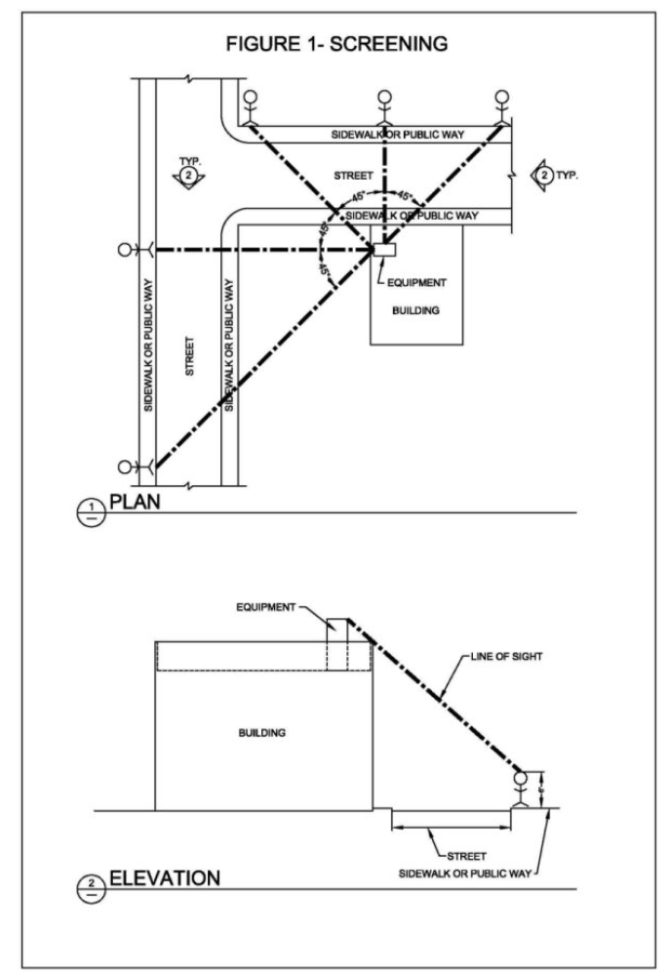

(Ord. 1551, 8-15-2017; amd. Ord. 1648, 6-21-2023)
15-2-9: PUBLIC FACILITIES:
The provisions of this title shall not be construed to limit or interfere with the installation, maintenance and operation of public utility pipelines and electric or telephone transmission lines or railroads when installed in compliance with title 11, chapter 3 of this Code and when located in accordance with the applicable rules and regulations of the Public Utility Commission of the State within rights-of-way, easements, franchises, or ownership of the public utilities; nor shall they, except as provided in title 11, chapter 3 of this Code, restrict the right of a public utility to increase the capacity of facilities necessary to and used directly for the delivery of or distribution of service. (Ord. 1212, 11-16-1993)
15-2-10: TEMPORARY BUILDINGS:
Temporary buildings are prohibited except for the following:
A. Temporary Real Estate Offices: One (1) temporary real estate office or construction trailer/mobile home may be located on any new subdivision or development site in any zone. The Director of Community Development shall be responsible for reviewing and approving said offices or trailer/mobile home, subject to any terms, conditions or special limitations deemed necessary.
B. Temporary Construction Buildings: Temporary structures, such as mobile homes or trailers for the housing of tools and equipment or containing supervisory offices in connection with a valid building or other permit issued by the Community Development Department, may be established and maintained as long as the permit is valid, and shall be removed within sixty (60) days after completion, or sixty (60) days after cessation of work.
C. Other Temporary Structures: Other temporary structures are permitted only in nonresidential zones, pursuant to section 13-1-2 (appendix chapter 31, division II) of this Code. Temporary structures installed or constructed for a period of three (3) months or more must be screened from the public view when required by, and in a manner subject to the approval of, the Director of Community Development. (Ord. 1245, 2-6-1996; amd. Ord. 1315, 1-18-2000; Ord. 1639, 9-20-2022)
15-2-11: DRIVEWAY VISIBILITY:
A. Triangle Area Required: To provide visibility for pedestrians and drivers, a visibility triangle must be formed along each side of the driveway located on the subject property. Within this area fences, walls, and landscaping must not be allowed to exceed thirty inches (30") in height from street grade, unless it is a tree which is trimmed to provide a minimum of twelve feet (12') of visibility from street grade under the canopy created by the branches.
B. Location And Description: The triangular area must be located adjacent to, but outside the driveway area, and must be described as follows: one (1) angle must be formed by the intersection of the driveway and the property line abutting the street, the sides of which must be ten feet (10') in length. The third side of this triangle must be a straight line connecting the two (2) other lines at their endpoints, see section 15-2-6, figure 1 of this chapter. (Ord. 1444, 8-3-2010)
15-2-12: CARNIVALS 1 :
A. Time Limit; Permit Required: Notwithstanding any other provisions of this title, carnivals sponsored by local nonprofit organizations shall be permitted on any property within the City zoned for uses other than residential, as an incidental or accessory use; provided, that such use does not exceed seven (7) calendar days, including erection and dismantling, in any one (1) calendar year; that the applicant applies for and receives a permit from the City Council to operate such carnival, and complies with all of the conditions imposed upon the issuance of said permits.
B. Operation Restrictions: The City Council shall not approve any such permit unless it finds that the operation will be conducted in the manner required by the permit and will not adversely affect the public peace, health, and safety of persons or property in the vicinity of the property on which the proposed carnival is to be located. (Ord. 1212, 11-16-1993)

Notes
1 | 1. See also subsection 4-2-9B of this Code.
15-2-13: CONDITIONAL USE PERMITS FOR AIRPORTS OR HELIPORT LANDING FIELDS:
A. Exception: The provisions of this section shall apply to all conditional use permits issued for helicopter landing facilities, with the following exception: Emergency, medical, police, fire and other public and private use of helicopter landing facilities with substantial public health and safety benefits shall be permitted within the City.
B. Evidence Required: Conditional use permits for helicopter landing facilities may be issued after satisfactory evidence has been presented to the Planning Commission demonstrating that:
1. The use of the helicopter landing facility shall not significantly increase community exposure to adverse health, safety, noise or nuisance impacts;
2. The use of the helicopter landing facility shall be accessory and incidental to the primary use of property;
3. The use of the helicopter landing facility for regularly scheduled commercial flight operations such as, but not limited to, bank operations and commuter passenger service operations, shall be prohibited;
4. The helicopter landing facility shall not be established within two thousand five hundred feet (2,500') of an existing permitted facility; and
5. The helicopter landing facility shall not be established in the area west of Sepulveda Boulevard and north of El Segundo Boulevard in the City.
C. Conditions: Conditional use permits issued for helicopter landing facilities shall be subject to the following conditions:
1. Flight operations of all helistops shall take place only during the hours of seven o’clock (7:00) A.M. to seven o’clock (7:00) P.M. Monday through Friday, except that operation may be permitted until nine o’clock (9:00) P.M., if necessary to accommodate a business emergency. If an operation is conducted between seven o’clock (7:00) P.M. and nine o’clock (9:00) P.M. Monday through Friday, for a business emergency, the permittee shall notify the Community Development Department on the next business day of the circumstances justifying that operation. Flight operations will not be allowed on New Year’s Day, Memorial Day, Labor Day, Thanksgiving or Christmas Day.
2. The intermittent use of helicopters for maintenance, construction, moving of equipment and other spot usage on Saturdays and Sundays and outside of specified operating hours may be allowed subject to prior reasonable notification and approval by the City.
3. Each operator of a helicopter landing facility shall provide to City and keep current:
a. The name and phone number of a contact person available twenty four (24) hours per day;
b. A list of helicopters using the facility, together with their corresponding identification numbers; and
c. The noise and performance specifications of said helicopter.
4. A “Fly Neighborly Program” shall be filed with the City prior to the commencement of operations and approved by the Director of Community Development and the City’s Noise Abatement Officer. The program shall emphasize noise abatement and community awareness through actions in at least the following areas:
a. Pilot awareness and sensitivity to community concerns;
b. Pilot training and flight operation planning; and
c. Public information.
5. All helicopters using the landing facility shall have large size identification (“N”) numbers, a minimum of twelve inches (12") in size on the bottom of the craft, except for helicopters which use the landing facility less than five percent (5%) of total operations of the facility per month.
6. All helicopters using the landing facility shall be equipped with a Mode A/3 transponder with Mode C altitude reporting capabilities.
7. Helicopter landing facility owners and operators shall enter into an indemnification agreement with the City and shall provide adequate proof of liability insurance to the approval and satisfaction of the City Attorney.
8. All CUPs for helicopter landing facilities may be reviewed by the Planning Commission every two (2) years. A monitoring report shall be prepared by the applicant and submitted to the Community Development Department upon request of the City. Such report shall consist of data on the types of helicopters using a facility, hours of operation, performance standards, number of monthly flights, and all other relevant data as determined by the City.
9. Any other conditions reasonably related to the operation of the helicopter landing facility. (Ord. 1212, 11-16-1993; amd. Ord. 1315, 1-18-2000; Ord. 1639, 9-20-2022)
15-2-14: LANDSCAPING:
A. Requirement; Purpose: The goal of this section is to ensure that adequate landscape areas and permanent water efficient irrigation systems are provided for all nonresidential development. The area extending between a building and property lines must contain both softscape and hardscape landscape materials, except for those portions devoted to vehicular parking and loading. All softscape area provided for each project site in nonresidential zoning districts must be natural plant material, preferably native to the area and not include artificial turf or synthetic grass except as otherwise provided in this title. All nonresidential landscape projects must comply with chapter 15A of this title relating to water conservation in landscaping.
B. Components: To achieve these purposes, the landscape criteria is divided into the following components:
1. Vehicular Use Areas: All surface vehicular use areas (VUA) shall provide landscape areas including shade trees and permanent irrigation systems, to cover five percent of the VUA. Landscaping shall be distributed uniformly throughout the VUA, and shall be in addition to the required property perimeter and building perimeter landscaping. There shall be one tree for every 3,000 square feet of VUA. These trees shall be evenly distributed throughout the automobile parking area to provide shade and provided around the perimeter of truck loading/waiting areas to provide screening. Individual tree and planter areas shall not be less than three feet in width, excluding curbs.
2. Building Perimeter: In those instances where setbacks are provided, all buildings, including parking structures, shall have landscape areas and permanent irrigation systems around their perimeter. A minimum horizontal depth of five feet of landscape materials, excluding curbs, shall be provided around the buildings, except additions to buildings in the rear one-third of a lot, which do not abut residential property, where landscaping would not be visible from the public right-of-way need not provide building perimeter landscaping in the rear. A combination of soft and hard landscape materials may be installed, provided the use of such materials form a cohesive, attractive and functional design.
3. Property Perimeter: All required setback areas must be landscaped as required by chapter 15A of this title. In addition, the landscaping must incorporate the theme utilized for the public rights-of-way and one shade tree must be provided for every 25 feet of street frontage. The following encroachments are permitted into the landscaped setback areas:
a. Parking spaces, including spaces for automobiles, bicycles, and shared mobility devices, may encroach into a required street-facing setback up to a maximum of 50 percent of the required setback area, provided a minimum landscaped setback of five feet is maintained. These spaces may encroach into a required interior side and rear setback up to the interior side or rear property line, provided that the interior side and rear property line does not abut a public or private street.
b. "Architectural landscape features", as defined in section 15-1-6 of this title, may encroach into the landscaped setback area up to a maximum of 80 percent of the required setback distance, provided a minimum landscaped setback of five feet is maintained. The features may cover a maximum of 25 percent of the total setback area, and be a maximum of 20 feet in height. Encroachments which exceed any of these standards, or which contain an open roof covering or side walls with greater than 20 percent component solid portions, requires the approval of an adjustment, as provided in chapter 22 of this title.
A combination of soft and hard landscape materials may be installed, provided the use of such materials will form a cohesive, attractive and functional design. Such design is to be integrated with and, if appropriate, physically connected to that provided for the building and VUA areas.
4. Minimum sizes for plant material:
a. The minimum tree container size for all trees on a site must be provided as follows:
(1) At least 20 percent of the trees must be 36-inch box size or larger.
(2) At least 30 percent of the trees must be 24-inch box size or larger.
(3) The remaining 50 percent must be 15 gallon size or larger.
(4) The Director may approve smaller tree container sizes than required based on site conditions, however no tree may be smaller than a 15 gallon size.
b. Shrubs must be planted from a minimum five gallon size container. One gallon size containers may be allowed for shrubs that are not commonly available in five gallon size containers, subject to approval by the Director. (Ord. 1257, 6-18-1996; amd. Ord. 1444, 8-3-2010; Ord. 1515, 12-15-2015; Ord. 1551, 8-15-2017; Ord. 1620, 11-17-2020; Ord. 1639, 9- 20-2022; Ord. 1648, 6-21-2023)
15-2-15: OUTDOOR DINING AREAS:
All outdoor dining facilities on private property must comply with the following:
A. Walkway Width: Any surfaced pedestrian walkway on private property abutting an outdoor dining area must maintain a minimum width of forty eight inches (48"), as set forth in section 3325 of title 24 of the California Administrative Code.
B. Blocking Ingress Or Egress: No placement of tables, chairs, umbrellas, etc., for outdoor dining shall be allowed in areas required for ingress and egress by the Uniform Building Code (UBC).
C. Overhead Elements: All overhead elements of the outdoor dining area, such as umbrellas, shall provide a minimum vertical height clearance of eight feet (8'), as set forth in section 3206.4 of the 1997 Uniform Building Code. No horizontal part of the overhead elements may protrude beyond the outdoor dining area.
D. Outdoor Dining Area: The outdoor dining area shall be kept clean and free of trash, etc., at all times, pursuant to title 7, chapter 4 of this Code.
E. Tables And Chairs:
1. Maintenance: All tables, chairs, and any other facilities in the outdoor dining area must be maintained in good repair, subject to the approval of the Director of Community, Economic and Development Services, pursuant to title 7, chapter 4 of this Code.
2. Closing Hours; Placement Inside: All tables, chairs, and umbrellas must be placed in a secure area or inside a building or structure when the business is closed.
F. Alcoholic Beverages: Any sales or services of alcoholic beverages in the outdoor dining area requires prior approval and a license issued by the city pursuant to chapter 22 of this title, and the State Department of Alcohol Beverage Control (ABC).
G. Entertainment Or Dancing: No entertainment or dancing is permitted in the outdoor dining area without prior approval from the Chief Financial Officer and the Director of Community Development, pursuant to title 4, chapter 8 of this Code.
H. Amplified Sound: No amplified sound is permitted in the outdoor dining area without prior approval of the Director of Community Development, pursuant to title 7, chapter 2 of this Code.
I. Public Property: All outdoor dining facilities on public property shall comply with all the requirements of title 9 of this Code, as well as any applicable policies of the City. (Ord. 1279, 10-7-1997; amd. Ord. 1315, 1-18-2000; 2000 Code; Ord. 1620, 11-17-2020; Ord. 1639, 9-20-2022; Ord. 1648, 6-21-2023)

